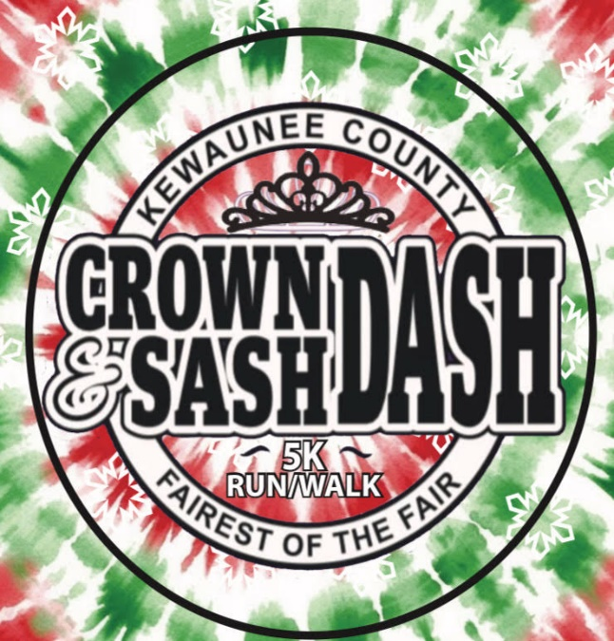

*A fun event that gives you an opportunity to let loose &

break out the formal wear hanging in the back of your closet!

**Formal wear is not required.**

**10th Annual**

**Crown and Sash Dash**

**Saturday, July 12, 2025**

**Registration:6:30am-8:00am**

**The race starts at 8:30 am**

# Kewaunee County Fairgrounds, Luxemburg, WI.

# For more information visit

# Kewauneecountyfair.com

**Proceeds Benefit:**

Kewaunee County

Fairest of the Fair Program

**Find us on**

